

Country level
Guidelines on description of foods and recipes

In GloboDiet, foods, recipes and dietary supplements are described using a series of facets (e.g. preservation method, cooking method) and their possible answers called descriptors (e.g. fresh, raw) which are defined according to the level of precision that
- the subjects are able to provide and
- the project needs to analyse the consumption data.

The description rules are then defined by food/recipe or group or sub-sub-groups, depending on the need.

For each project, the coordinator decides the common sets of facets and descriptors and how they will be used in each (sub-sub-) group. At the country level, there is essentially a need to translate and adapt the common rules, depending on the GloboDiet databases.

Facets and descriptors – Foods, recipes and dietary supplements

The facets and their descriptors, how they are used and more detailed definitions, are listed in the THESAURUS, Appendix 1 of GloboDiet user manual (provided separately).

For foods, the common file containing all facets and descriptors used in a given project is called FADECODE.END, for recipes, RCPFADECODE.END (alternatively R_FACETS.xls and R_DESCFACE.xls) and for dietary supplements DS_FACET.xls and DS_DESCFACE.xls.
They are prepared in both English and your local language(s) in order to ensure standardization and prevent loss of meaning through translation.

Actions:
Select the facets and related descriptors from the library common file THESAURUS, Appendix 1.
Once the lists of facets and the descriptors needed are stabilised, translate them to your language(s).
Prepare your local Thesaurus which will be provided as an annex of the GloboDiet user’s manual to the local interviewers.

To help the interviewers to describe foods and recipes, some text can be displayed by positioning the mouse of the question mark (see Figure below). You may provide the corresponding text. Each message is 300 characters long max.
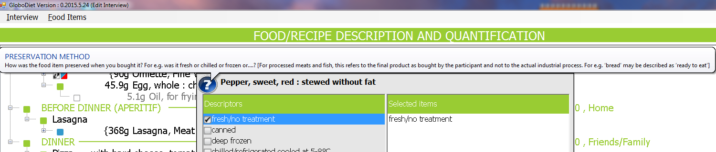

Facets and descriptors by food groups and by recipe groups

Format of FADEBYGROUP or RCPFADEBYGROUP.end file:
- columns 1-6: GloboDiet classification group
- columns 9-10: facet code
- columns 13-14: descriptor code
- column 17: D = Default descriptor, the most common one per facet of that group. The cursor will be on this descriptor when a window with the group of related facet descriptors is proposed in GloboDiet.
- column 20: N = descriptors which will not be displayed after the name of the item when listed on the screen during the interview (N=Not in the name). It is IARC who sets whether the descriptor name appears on the screen or not. These descriptors either do not give much information (e.g. undefined), or refer to the usual state of the item (= Default), or are redundant with other descriptors (canned ...). For example, when describing a “potato” as fresh, flesh and boiled, its description appears simplified on the screen where items are described and quantified (Fresh and Flesh are coded “N”). See below:
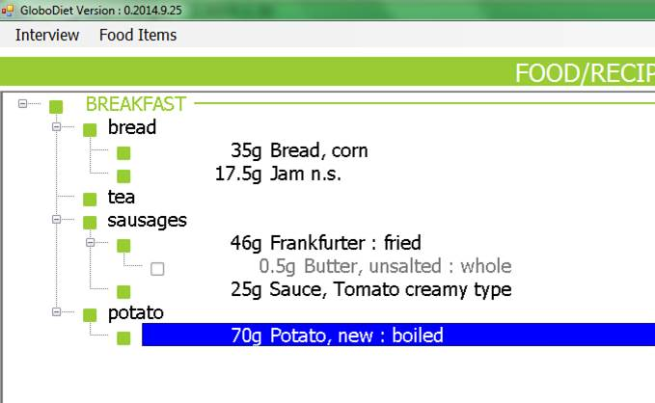
- column 23: group label
- column 25: facet label sometimes followed by a condition [IF…] if not asked all the time
- column 27: descriptor label

Foods (FADEBYGROUP)

Based on your FADECODE.end and common standardisation rules, IARC will prepare a proposal FADEBYGROUP.end. This file remains in English.

Open the FADEBYGROUP.END. This file lists all facets and descriptors that could be relevant to be used for each food group or sub-sub-group. The facet order has been pre-determined purposefully by IARC based on years of experience thus should not be changed.
Note that within each facet, a selection of relevant descriptors for each food group has been made.

Actions:
As national coordinators, you will have to decide for each facet and depending on the food (sub-sub-) group
- The list of descriptors is pre-entered by IARC but you may adapt it further using descriptors listed in your FADECODE.end. Track the changes (additions and deletions) made.

- What will be the default descriptor, if any. The cursor and highlighting will be on this descriptor when opening a new window FACET in the GloboDiet application during the interview, ready to be quickly selected thus potentially speeding up the interview. This default descriptor cannot be ‘undefined’ and if possible neither should be ‘n.s.’. The choice of the default descriptor is driven by the expected frequency of reporting (i.e. most common specific descriptor should ideally be chosen as a default). We advise to group other common descriptors around this default so that they can be reached easily during the interview. If very few descriptors are available (e.g. facet 13 skin consumed), a default descriptor may not help much. On the opposite, we are aware that there are some instances where choosing a default descriptor is difficult (e.g. long list of descriptors of facet 06). Therefore a default is not mandatory. If a default descriptor is not chosen, the default position of the cursor/highlighting will be at the top of the descriptor list.

- The order of the descriptors according to your local needs, to ease the interview.

  - For long lists (e.g. facet 06 Flavoured/added component), you may choose the alphabetical order (however think of the alphabetical order of the descriptors when translated in your language rather than the English descriptors). A search bar is available for facets having many descriptors. The software searches in the list the descriptors containing the string typed in the search bar:

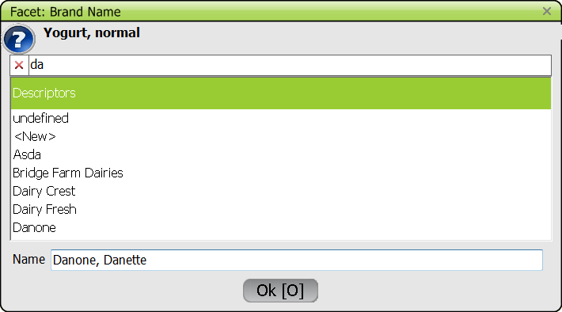

- For short lists, organise the most common descriptors around the default descriptor. Descriptors 'undefined' should be listed at the end of the list (or close to the end) rather than at the top to avoid being chosen as the default because it does not provide any specific information and could be chosen by mistake if left on top.

- Note that some descriptors are not listed in the FADEBYGROUP.END
- Brand name list:
  - The descriptors are listed in a separate file BRANDNAME prepared while working on the food list.
  - They will be displayed in alphabetical order and a search bar is available, as shown above.
- Lists of fats and liquids (facets 15 and 16):
  - The descriptors are taken for the food list. By default, fats are taken from group 10 Fats and 0507 Creams and liquids are taken from 0501 Milks, 0502 Milk substitutes, 0503 Yoghurts, 0504 Fromage blanc, 0507 Creams, group 13 Non-alcoholic beverages, group 14 Alcoholic beverages and 1602 Stocks . As coordinators, you have to provide your choices.
  - They will be displayed in alphabetical order; the generic items (GI) are listed as the bottom of the list – in alphabetical order also. A search bar is available, as shown above.
  - Besides the food list items, a few descriptors (e.g. “no fat used”) are in the FADEBYGROUP. They are inserted at the top of the list before the food list items and should not impede the alphabetical search (if you type ‘n’, in this example, when the cursor is on the descriptor list, the cursor may find “no fat used” at the top instead of finding a fat starting by ‘n’) . A trick to avoid this is either to use the search bar rather the alphabetical search directly in the list or to insert ‘-‘ before the common descriptors: “-no fat used”. In the example below, “milk/liquid n.s.” has been renamed “-milk/liquid n.s.” to enable to reach the specific “milk” items when typing ‘m’:

  - 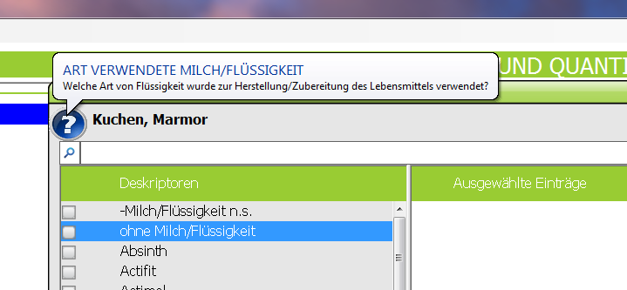

- Check the rules indicated in brackets [IF…]. Some facets will be asked based on previous answers, for example the facet “brand name” will be asked if the item is “commercial”, but also if “from take-away” … See if the rules make sense or need to be deleted, or extended to other facet-descriptors. Track the changes (additions and deletions) made.

N.B.:
- if you wish to add a facet and/or a descriptor – not listed in your FADECODE.end, please contact the international coordinator to ask for this new facet/descriptor. A note can also be left in the file for the IARC staff.

Recipes (RCPFADEBYGROUP)

Based on your RCPFADECODE.end and common standardisation rules, IARC will prepare a proposal RCPFADEBYGROUP.end. This file remains in English.

Open the RCPFADEBYGROUP.END. This file lists all facets and descriptors that could be relevant to be used for each recipe group. The facet order has been pre-determined purposefully by IARC and should not be changed.
Note that within each facet, a selection of relevant descriptors for each recipe group has been made.

Actions:
As national coordinators, you will have to decide for each facet and depending on the recipe group

- The list of descriptors is pre-entered by IARC but you may adapt it further using descriptors listed in your RCPFADECODE.end. Track the changes (additions and deletions) made.

- What will be the default descriptor, if any.

- The order of the descriptors according to your local needs, to ease the interview.

- Check the rules indicated in brackets [IF…]. Track the changes (additions and deletions) made.

Dietary supplements

For dietary supplements, all facets and descriptors defined in DS_FACET and DS_DESCFACE are available by default for all items. This is handled by IARC.

Facets by foods and recipes

Foods (FDFACET)

At the project level, decisions on what facets and descriptors are proposed for each food (sub-sub-) group have been taken for foods (point 2. above).

Actions:
As national coordinators, you will have to decide for each food of your food list what facet(s) to keep out of those foreseen at the food (sub-sub-) group level.
You have to go through the list of facets proposed and remove irrelevant facets.

Open the FDFACET.END. This file contains your food list and the facets codes as defined by default at the level of the food (sub-sub-)group in the FADEBYGROUP.END file. You have to go through FDFACET.END and keep for each specific food only the relevant facet codes. Track the changes (deletions) made.
On the other hand, you cannot add a facet not proposed by default at food (sub-sub-) group level - if you wish to add a facet, please contact the international coordinator to ask for this new facet (since it would first need to be added to the FADEBYGROUP.END file).
Do not change the order of the facets either.

EXAMPLE :

group 05 03 01 06 10 12 07 08 11 (default values as given in FADEBYGROUP.END)

Yoghurt, Greek 06 12 07 08
Yoghurt, regular 01 06 10 12 07 08

Facet code 01 corresponding to the facet "Source" was deleted from the Greek yoghurt because this is the only kind in your country thus is implicit in the name; the code 11 of the facet "Enriched/fortified" was deleted because enrichment is not found in your country for this food, according to the legislation. Note that the regular yoghurt may be made with different kinds of milk, so facet 01 is kept, and may be homemade, so facet 10 Food production is kept.
Special remark: be aware that there is a condition in FADEBYGROUP.END:
facet 12 BRANDNAME/PRODUCTNAME [IF food production = commercial]
- where facet “food production” is facet 10. So whenever facet 10 is kept, facet 12 must be available, in case the answer to facet 10 is commercial, to ask the brand.

GENERAL COMMENTS
- consider having all the facets proposed for the generic items
- consider having a minimum common description within a group (e.g. ask the facet Cooking method for all vegetables) so that the answer is coded/exported for analyses and not just implicit.
- keep the facets that are linked to quantification (02 ‘physical state as estimated’, 03 ‘cooking method’, 13 ‘skin consumed’) to be able to use the correct coefficients (density, edible part, raw-to-cooked) when relevant and quantification methods (e.g. the photo 15 Tomato slices is usually proposed for raw foods only so the item “tomato” must be described “raw” to be able to select photo 15).
- Facet 02 "Physical state as quantified" is absolutely necessary during the FOOD quantification step for some food groups – see your project FDQMDETAIL file and the Guidelines on quantification; so the facet 02 should not be deleted for these food groups (for example the sub-group 08 01 Fish). When it is implicit in the name or not needed (e.g. French fries) this facet can be deleted.
- Facet 03 " Cooking method" is necessary to take into account the raw-to-cooked coefficient and the fat absorbed during cooking (depending on the cooking method), so this facet should not be deleted unless completely inappropriate and not linked to quantification.
For group 05 Dairy products: it is generally needed only for food safety reasons. In clear only for raw milk (not heat treated). This means the cooking method question can be skipped for many dairy items. There is no raw-to-cooked issue for that group.
- be aware that some facets are linked to other ones by rules, for example 1) the facet 12 ‘BRANDNAME’ may be asked only if the facet 10 ‘food production’ descriptor is commercial or 2) facet 04 'preservation method' must always be followed by facet 05 'packing medium'.
- choices should be done independently from the level of descriptive detail available in your national food composition table, rather think of what is actually available on the market for consumption, n what the subject can report.
- if a facet is chosen for a given food, all the descriptors as they appear in the FADEBYGROUP.END file for its food (sub-sub-) group will be proposed.
- be aware that new products may appear on the market, therefore you may have to leave facets such as Fat content, Sugar content to be able to describe properly these new products.
- Facet 08 'fat content' collects the information on the intrinsic fat content of the food item while facet 15 'Type of fat used' enables to enter the fat used during preparation, but not cooking, of the food (e.g. a cake).
If facet 15 is selected, all the fats and dairy creams from the food list (and their shadow items) would be displayed on the screen, along with the descriptor 'no fat used', for the interviewer to select the corresponding choice(s) as provided by the subject.
Facet 08 helps discriminate between commercial products (e.g. regular vs. fat reduced). For example, the subject could know that on the packaging of the Potato crisps that he/she consumed it was written `Potato crisps, 30% fat less, precooked in sunflower oil', the information about the fat content and the type of fat used for precooking can be entered using these two facets, respectively.
- Facet 06 Flavoured/added component is one of the first questions asked during the 24HR. It usually applies to commercial and complex foods (including puree).
- Facet 13 is not needed for items always eaten without skin (e.g. banana) or not applicable (e.g. strawberry).
- Facet 10 is used to get the information on where complex foods (e.g. breads, cakes, pasta, compote, puree…) and fruit juices are prepared. It is not relevant for basic agricultural crop-type foods (e.g. rice, grain, meat cut). Depending on your project rule, compotes and purees may either be in the name or described; in both cases you should be have facet 10 available, either linked to e.g. “puree, potato” or to “potato”, respectively.
- For group 07 Meat and meat substitutes: facet 13 Skin/peel/edible casing/edible rind consumed is relevant for poultry cuts and pork ham for example which can be eaten with or without the skin/edible rind; facet 14 Visible fat consumed is applicable if the meat cut contains visible fat which can be easily removed like in a pork chop or a slice of ham.

b. Recipes (RCPFACET)

At the project level, decisions on what facets and descriptors are proposed for each recipe group have been taken for recipes (point 2. above).

Actions:
As national coordinators, you will have to decide for each recipe of your recipe list what facet(s) to keep out of those foreseen at the recipe group level.
You have to go through the list of facets proposed and remove irrelevant facets.

Open the RCPFACET.END. This file contains your recipe list and the facets codes as defined by default at the level of the recipe group in the RCPFADEBYGROUP.END file. You have to go through RCPFACET.END and keep for each specific recipe only the relevant facet codes. Track the changes (deletions) made.
On the other hand, you cannot add a facet not proposed by default at recipe group level- if you wish to add a facet, please contact the international coordinator to ask for this new facet (since it would first need to be added to the RCPFADEBYGROUP.END file).
Do not change the order of the facets either.

GENERAL COMMENTS
- Facet 01 ‘Recipe production’ is mandatory for the GloboDiet programme. It has to be kept.
- Facet 00 ‘Known/unknown’ is mandatory for Open recipes. Do not list it for the other types of recipes.
- consider having a minimum common description within a group (e.g. ask the facet Reheating method for all recipes based on meat, as subject could consumed recipes as left overs)
- be aware that some facets are linked to other ones by rules, for example the facet BRANDNAME may be asked only if the recipe production descriptor is commercial
- if a facet is chosen for a given recipe, all the descriptors as they appear in the RCPFADEBYGROUP.END file for its recipe group will be proposed.

